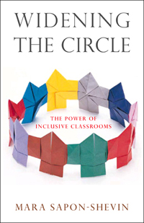
SCHEDULE
8:00-8:30 Continental Breakfast/Registration
8:30-10:00 Keynote: Mara Sapon-Shevin
10:00-10:20 Morning Break
10:20-12:00 Keynote: Mara Sapon-Shevin
12:00-12:45 Lunch/ Book Signing
12:45-1:45 Breakout Session I
1:45-2:00 Break
2:00-3:00 Breakout Session II
3:00-3:15 Closing and Evaluations
Breakout Session Topics:
- Systems Change and Inclusion
- Advocating for Inclusion
- Elementary Co-Teaching
- Secondary Co-Teaching
- Including Bilingual Students
Widening the Circle The Power of Inclusive Classrooms
Mid-West Regional Task Force on Quality Inclusive Schooling
May 7, 2008
8:00 am-3:15 pm
Burgundy Basin Inn
Bushnell’s Basin, NY

For more information, please contact:
Cyndi Besig
Cyndi_Besig@boces.monroe.edu
Jackie Czamanske
Jackie_Czamanske@boces.monroe.edu
Ann Monroe-Baillargeon
monroe@alfred.edu

